LAB EXPERIMENT RECORD

SET 30: MOBILE APP USAGE ANALYSIS

Particulars | Details
Department | CSE – AI & DS
Course Code / Course Name | DSA0206 / Data Handling and Visualization
Experiment | Data Visualization using R
Name | M V Raghavan
Register Number | 192424373
Date | 15 OCTOBER 2026
Day | Thursday

Aim
To analyze mobile application usage by visualizing screen-time distribution, examining the relationship between data usage and screen time, comparing average satisfaction by gender, and outlining an interactive Tableau dashboard.

Dataset: Mobile_App_Usage.csv
User_ID | Gender | Age | Screen_Time (hrs) | App_Usage_Count | Data_Used (GB) | Satisfaction | Usage_Date
U01 | Male | 20 | 4.5 | 18 | 2.4 | 3 | 2025-01-08
U02 | Female | 22 | 6.0 | 25 | 3.8 | 5 | 2025-01-08
U03 | Male | 19 | 3.2 | 12 | 1.6 | 3 | 2025-02-11
U04 | Female | 21 | 7.1 | 30 | 4.5 | 5 | 2025-02-11
U05 | Male | 23 | 2.8 | 10 | 1.2 | 2 | 2025-03-14
U06 | Female | 20 | 5.4 | 22 | 3.1 | 4 | 2025-03-14

PROGRAM 1: Histogram and Density Plot of Screen Time
To visualize the distribution of users' screen time using a histogram and overlay a density curve.
# Import the CSV file
data <- read.csv(file.choose(), stringsAsFactors = FALSE)

# Histogram of Screen Time hist(data$Screen_Time,
probability = TRUE,
main = "Distribution of Mobile App Screen Time", xlab = "Screen Time (Hours)",
ylab = "Density", col = "lightblue", border = "white")

# Add density curve lines(density(data$Screen_Time),
col = "red", lwd = 2)

legend("topright",
legend = "Density Curve", col = "red",
lwd = 2)

Procedure: Run the program in RStudio. When the file picker opens, select Mobile_App_Usage.csv. The histogram displays the observed screen-time values, and the red curve provides a smoothed estimate of their distribution.
Observation / Result: Screen time ranges from 2.8 to 7.1 hours in this sample. The distribution has only six observations, so the density curve should be treated as a visual summary rather than a reliable estimate of the wider user population.
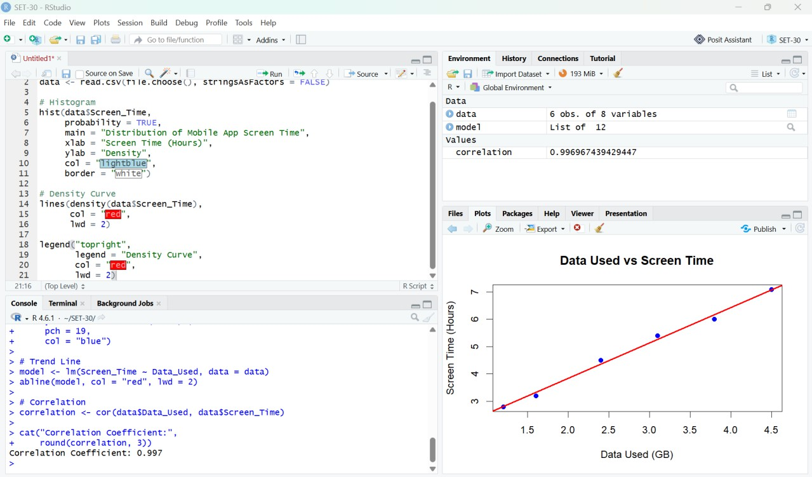
Figure 1. RStudio output: histogram and density curve for screen time.

PROGRAM 2: Scatter Plot of Data Used vs Screen Time
To investigate the relationship between mobile data usage and screen time, add a regression line, and calculate the Pearson correlation coefficient.
# Import the CSV file
data <- read.csv(file.choose(), stringsAsFactors = FALSE)

# Scatter plot
plot(data$Data_Used, data$Screen_Time, main = "Data Used vs Screen Time", xlab = "Data Used (GB)",
ylab = "Screen Time (Hours)", pch = 19,
col = "blue")

# Add regression line
model <- lm(Screen_Time ~ Data_Used, data = data) abline(model, col = "red", lwd = 2)

# Calculate correlation
correlation <- cor(data$Data_Used, data$Screen_Time)

cat("Correlation Coefficient:", round(correlation, 3), "\n")

Procedure: Run the code and choose Mobile_App_Usage.csv when prompted. The plot places data usage on the X-axis and screen time on the Y-axis. The red line is the fitted linear regression line; the correlation coefficient summarizes the direction and strength of the linear association.
Observation / Result: The supplied sample shows a very strong positive association between data used and screen time (approximately r = 0.997). Users with higher data usage also tend to have longer screen time. This small sample does not establish causation.
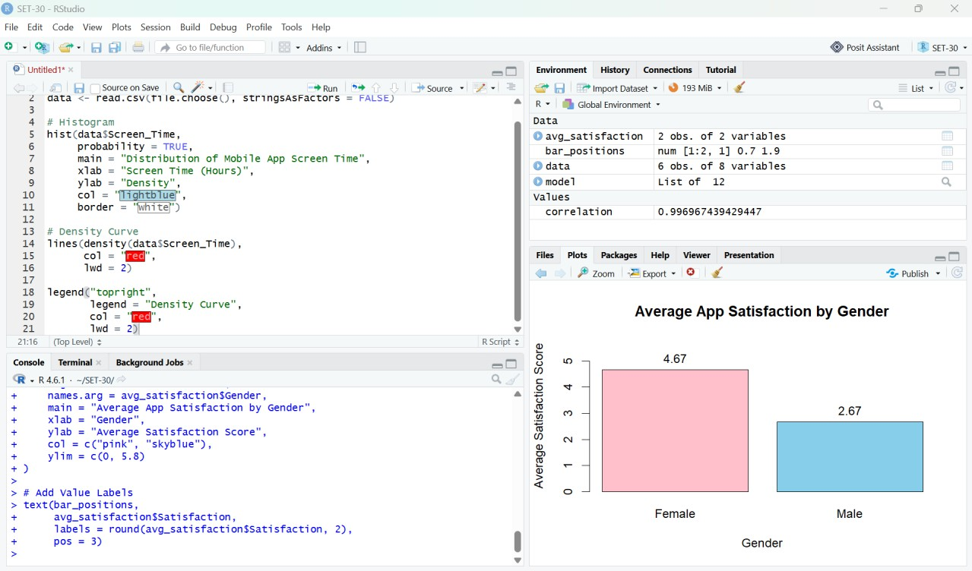
Figure 2. RStudio output: data usage versus screen time with regression line.

PROGRAM 3: Average Satisfaction by Gender
To calculate the average satisfaction score for each gender and display the averages in a labeled bar chart.
# Import the CSV file
data <- read.csv(file.choose(), stringsAsFactors = FALSE)

# Calculate average satisfaction by gender avg_satisfaction <- aggregate(
Satisfaction ~ Gender, data = data,
FUN = mean
)
print(avg_satisfaction) # Bar chart
bar_positions <- barplot( avg_satisfaction$Satisfaction, names.arg = avg_satisfaction$Gender,
main = "Average App Satisfaction by Gender", xlab = "Gender",
ylab = "Average Satisfaction Score", col = c("pink", "skyblue"),
ylim = c(0, 5.8)
)

# Add value labels text(bar_positions,
avg_satisfaction$Satisfaction,
labels = round(avg_satisfaction$Satisfaction, 2), pos = 3)

Procedure: Run the code and select Mobile_App_Usage.csv. The aggregate() function calculates the mean satisfaction score for each gender. The bar chart shows the averages, and the labels above the bars show the exact values.
Observation / Result: The female users' average satisfaction is 4.67, while the male users' average is 2.67. In this sample, female users report higher satisfaction. There are only three users in each group, so the result should not be generalized to all users.
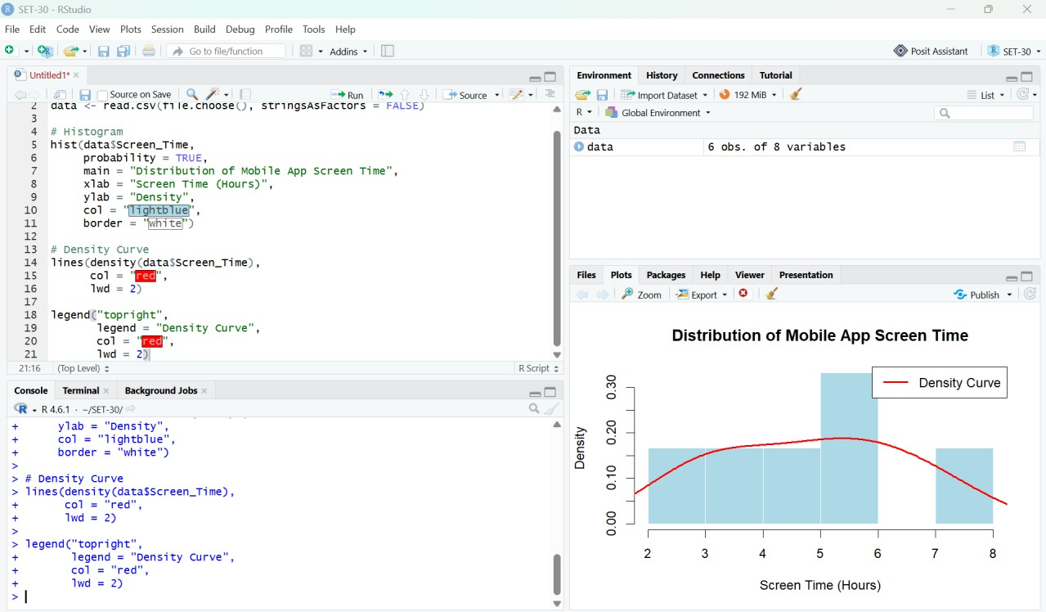

Figure 3. RStudio output: average app satisfaction by gender.

PROGRAM 4: Interactive Tableau Dashboard
To create an interactive dashboard containing a bubble chart of screen time versus data used and a line chart showing usage trends, with filters for gender and usage date.

Procedure
- Run the export code below in RStudio to create the CSV file.
- Open Tableau Desktop or Tableau Public and connect to Mobile_App_Usage.csv.
- Create a worksheet named “Screen Time vs Data Used”. Drag Data_Used (GB) to Columns and Screen_Time (hrs) to Rows; select Circle in the Marks card.
- Drag Gender to Color and App_Usage_Count to Size. Add User_ID to Detail and include all relevant fields in the tooltip.
- Create a second worksheet named “Usage Trends”. Drag Usage_Date to Columns and Screen_Time (hrs) to Rows; use a line chart. If multiple users share a date, choose an appropriate aggregation such as Average.
- Create a dashboard and place both worksheets on it. Add filters for Gender and Usage_Date and apply them to both worksheets.
- Add a descriptive dashboard title, verify tooltips and filters, then save the Tableau workbook.

Export CSV from R
# Save the data frame as a CSV file
write.csv(data, "Mobile_App_Usage.csv", row.names = FALSE)

# Show the folder where the file was saved getwd()

Result: The Tableau dashboard allows users to compare screen time with data consumption, identify differences by gender and app-usage count, and explore screen-time values across usage dates.

Overall Procedure
- Prepare or import Mobile_App_Usage.csv with the eight specified columns.
- Run Program 1 to generate the histogram and density curve.
- Run Program 2 to generate the scatter plot, regression line, and correlation coefficient.
- Run Program 3 to calculate and plot average satisfaction by gender.
- Export the data to CSV if needed, then build and save the Tableau dashboard.

Overall Result
Mobile app usage data was analyzed using a histogram with density curve, a scatter plot with regression line, and a bar chart of average satisfaction by gender. The sample indicates a strong positive association between data usage and screen time, and higher average satisfaction among female users in this dataset. An interactive Tableau dashboard can combine these views with Gender and Usage_Date filters.
Note: The three inserted screenshots are the RStudio screenshots supplied for this task. They are placed beside the corresponding program sections. The screenshot showing the scatter plot was matched to Program 2, the histogram screenshot to Program 1, and the satisfaction bar chart to Program 3.

